**Chapter 1**

**Functions and Graphs**

**1.2 Basic Classes of Functions**

**Section Exercises**

**For the following exercises, for each pair of points, a. find the slope of the line passing through the points and b. indicate whether the line is increasing, decreasing, horizontal, or vertical.**

59.  and 

Answer: a. –1 b. Decreasing

61.  and 

Answer: a. 3/4 b. Increasing

63.  and 

Answer: a. 4/3 b. Increasing

65.  and 

Answer: a. 0 b. Horizontal

**For the following exercises, write the equation of the line satisfying the given conditions in slope-intercept form.**

67. Slope  passes through 

Answer: 

69. Slope  passes through 

Answer: 

71. Passing through  and 

Answer: 

73. -intercept  and -intercept

Answer: 

**For the following exercises, for each linear equation, a. give the slope  and -intercept *b*, if any, and b. graph the line.**

75. 

Answer: a.  b.

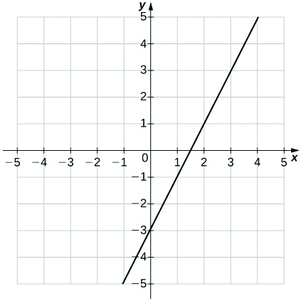

77. 

Answer: a.  b.

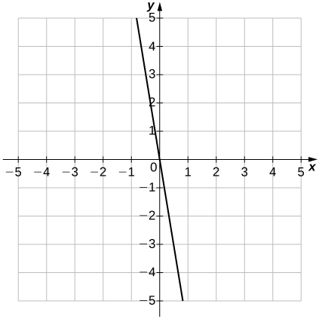

79. 

Answer: a.  b.   
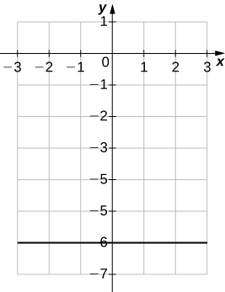

81. 

Answer: a.  b.

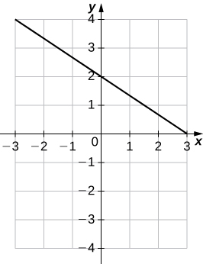

**For the following exercises, for each polynomial, a. find the degree; b. find the zeros, if any; c. find the -intercept(s), if any; d. use the leading coefficient to determine the graph’s end behavior; and e. determine algebraically whether the polynomial is even, odd, or neither.**

83. 

Answer: a. 2 b.  c. –5 d. Both ends rise e. Neither

85. 

Answer: a. 2 b.  c. –1 d. Both ends rise e. Even

87. 

Answer: a. 3 b. 0,  c. 0 d. Left end rises, right end falls e. Odd

**For the following exercises, use the graph of  to graph each transformed function **

89. 

Answer:

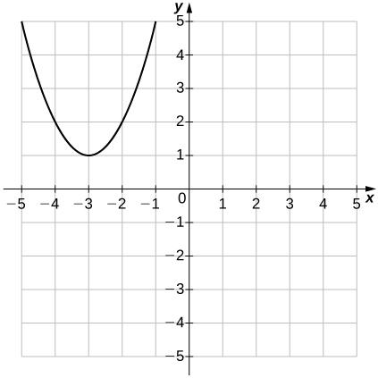

**For the following exercises, use the graph of  to graph each transformed function **

91. 

Answer:

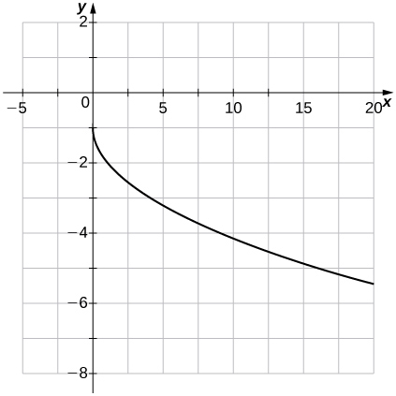

**For the following exercises, use the graph of  to graph each transformed function **

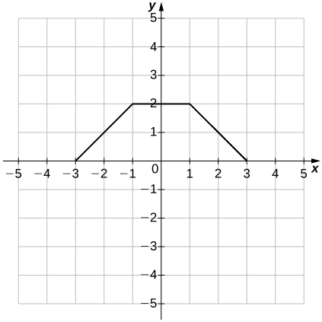

93. 

Answer:

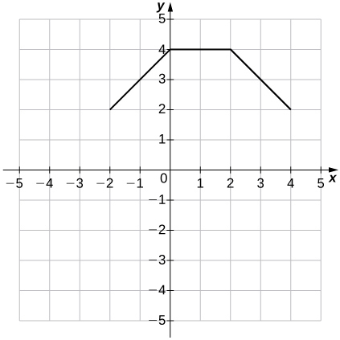

**For the following exercises, for each of the piecewise-defined functions, a. evaluate at the given values of the independent variable and b. sketch the graph.**

95. ; 

Answer: a.  b.

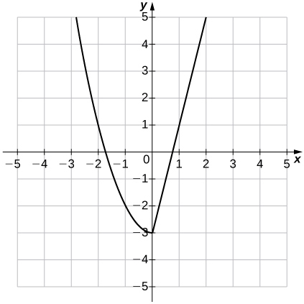

97. 

Answer: a.  b.

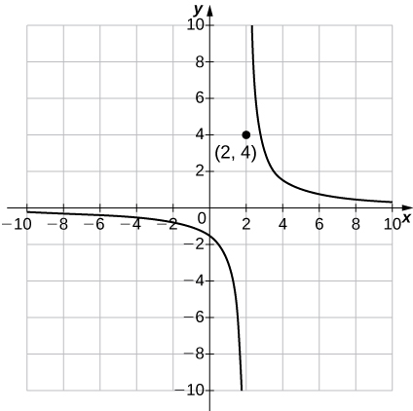

**For the following exercises, determine whether the statement is true or false. Explain why.**

99.  is an odd root function

Answer: True; 

101. A function of the form  where  is a real valued constant, is an exponential function.

Answer: False;  where  is a real-valued constant, is a power function

103. **[T]** A company purchases some computer equipment for $20,500. At the end of a 3-year period, the value of the equipment has decreased linearly to $12,300.

1. Find a function  that determines the value V of the equipment at the end of t years.
2. Find and interpret the meaning of the - and -intercepts for this situation.
3. What is the value of the equipment at the end of 5 years?
4. When will the value of the equipment be $3000?

Answer: a. b. means that the initial purchase price of the equipment is $20,500;  means that in 7.5 years the computer equipment has no value. c. $6835 d. In approximately 6.4 years

105. **[T]** A family bakery makes cupcakes and sells them at local outdoor festivals. For a music festival, there is a fixed cost of$125 to set up a cupcake stand. The owner estimates that it costs $0.75 to make each cupcake. The owner is interested in determining the total cost as a function of number of cupcakes made.

1. Find a linear function that relates cost C to x, the number of cupcakes made.
2. Find the cost to bake 160 cupcakes.
3. If the owner sells the cupcakes for $1.50 apiece, how many cupcakes does she need to sell to start making profit? (Hint: Use the INTERSECTION function on a calculator to find this number.)

Answer: a.  b. $245 c. 167 cupcakes

107. **[T]** A car was purchased for $26,000. The value of the car depreciates by $1500 per year.

1. Find a linear function that models the value V of the car after t years.
2. Find and interpret .

Answer: a. b. In 4 years, the value of the car is $20,000.

109. **[T]** The total cost *C* (in thousands of dollars) to produce a certain item is modeled by the function , where *x* is the number of items produced. Determine the cost to produce 175 items.

Answer: $30,337.50

111. **[T]** The output (as a percent of total capacity) of nuclear power plants in the United States can be modeled by the function , where *t* is time in years and  corresponds to the beginning of 2000. Use the model to predict the percentage output in 2015.

Answer: 96% of the total capacity

This file is copyright 2016, Rice University. All Rights Reserved.